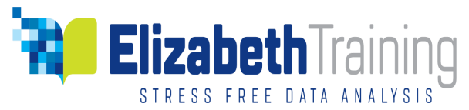
  Public Schedule Course Booking Request Form

Event Details
Title: | Please specify the title of the course
NVivo | Please the public training is delivered on the Newest version – 20.
Platform |  Windows  Mac
Course Date | Please specify your preferred date(s) as listed on the website.
Venue | Due to Covid_19, all Training is delivered Online.

Delegate Information
Full Name:
Email:
Phone:
Organisation /University

Cost
 | 2-Day Course | 1-Day Course | No of Delegates
Student delegate | £320.03 | £160.02
Academic delegate | £355.59 | £177.79
Commercial delegate | £391.14 | £195.57

Payment Options
Want to pay by credit card. You will be sent a payment link.
Please invoice against Purchase Order Number: ……………………….
Email of Finance /Purchasing department: ……………………………………….
Finance/purchasing department phone number: ….……………………………
Billing Address (please provide for invoicing) …………………………………………………………………………………………….
………………………………………………………………………………………………………

BACS Payment: Please make BACS payment to Data Solution Services, Santander Business Banking, Bridle Road, Bootle, Merseyside L30 4GB. UK Account no: 42107523, Sort Code: 09-06-66. International: Swift BIC: ABBYGB2LANB, IBAN: GB17ABBY 0906 6642 1075 23.

IT Facilities

NVIVO TRAINING
- All participants must join the online class with a working copy of the NVivo software.
- If participants do not have NVivo software, then a 14-day FREE license copy could be downloaded from the QSR website and installed.
SPSS STATISTICS TRAINING
- All participants must join the online class with a working copy of the SPSS.
- If participants do not have SPSS software, then a 14-day FREE license copy could be downloaded from the IBM SPSS website and installed.
IT Technical Support While in Class
Please note, we have no capacity to provide IT technical support for your computer, internet, and the software to be trained on in class. Please ensure before you join a class that you have a working computer with internet and the software you will be receiving training on is fully working.

Class Size
The ideal class size is a maximum of 9 participants.

Breaks Times
For Day courses, Morning coffee/tea break is at 11am for 10minutes. Lunch time is at 12:30 – 1:30pm and afternoon coffee/tea at 3pm for 10minutes.
For half day courses, 10mins at 11am or 3pm.

Terms and Conditions
- We require a Purchase Order Number to confirm booking if your organisation is paying.
- Alternatively we accept credit Card payment.
- Cancellation of a confirmed booking 3 working days to the course due date requires rescheduling, otherwise 50% of the training fee is charged.
- Cancellation within 24 hours of course due date is charged at the full amount.
If you have further queries, please contact training@elizabethtraining.co.uk.

